Ideation Phase
Define the Problem Statements

Date | 18 June 2026
Team ID
Project Name | Online Complaint Registration
Maximum Marks | 2 Marks

Customer Problem Statement Template:
Create a problem statement to understand your customer's point of view. The Customer Problem Statement template helps you focus on what matters to create experiences people will love.
A well-articulated customer problem statement allows you and your team to find the ideal solution for the challenges your customers face. Throughout the process, you’ll also be able to empathize with your customers, which helps you better understand how they perceive your product or service.
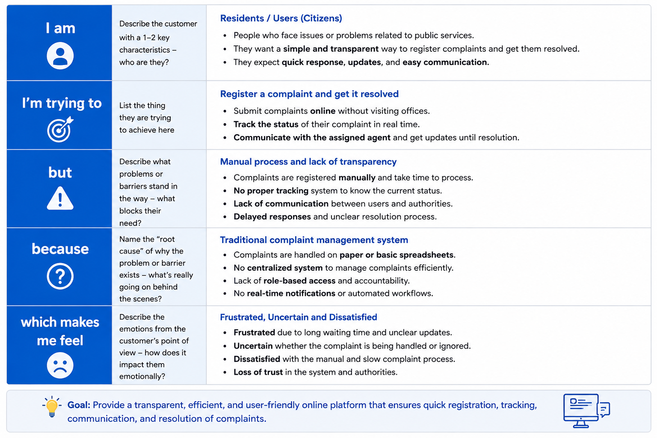
Reference: https://miro.com/templates/customer-problem-statement/
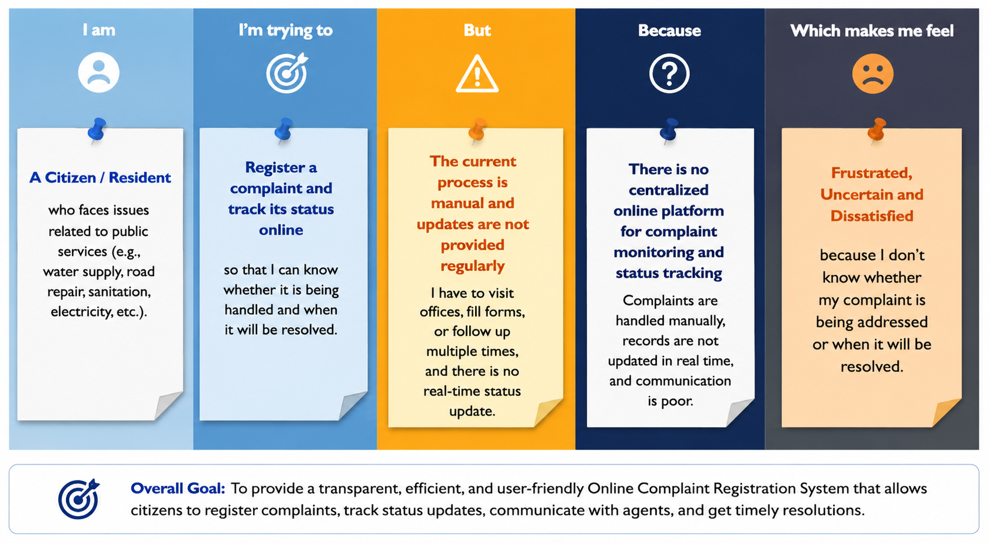

Problem Statement (PS) | I am (Customer) | I’m trying to | But | Because | Which makes me feel
PS-1  Lack of Transparency in Complaint Tracking | A citizen/resident who has raised a complaint regarding public services | Register a complaint and track its status online | The current complaint process is manual and updates are not provided regularly | There is no centralized online platform for complaint monitoring and status tracking | Frustrated, uncertain, and dissatisfied because I don't know whether my complaint is being addressed
PS-2  Poor Communication Between Users and Authorities | A complainant who needs updates regarding a submitted complaint | Communicate with the assigned agent and receive timely responses | There is no direct communication channel between users and complaint-handling authorities | Existing systems lack integrated messaging and notification features | Ignored and helpless because I cannot easily get information about my complaint

